Experiment No 6
Roll No:24141030 Lab: PL-II

Theory:

1. Introduction to Dictionaries
A dictionary is an unordered, mutable collection of key-value pairs enclosed in curly braces {}. Dictionaries are also known as associative arrays, hash maps, or hash tables in other programming languages. They provide fast lookup by key rather than by index.
Example:
student = {"name": "Alice", "age": 20, "course": "Python"}

2. Characteristics of Dictionaries
Property | Description
Unordered | Elements have no specific order (Python 3.7+ preserves insertion order)
Mutable | Can be modified after creation
Key-Value Pairs | Each element has a key and corresponding value
Unique Keys | Keys must be unique; duplicate keys are not allowed
Hashable Keys | Keys must be immutable (string, number, tuple)
Any Values | Values can be any data type (mutable allowed)

3. Dictionary Keys vs Values
Aspect | Keys | Values
Uniqueness | Must be unique | Can be duplicated
Mutability | Must be immutable | Can be mutable or immutable
Data Types | Strings, numbers, tuples | Any data type
Examples | "name", 101, ("x","y") | "Alice", [1,2,3], {1,2}

4. Creating Dictionaries
Method | Example
Using curly braces | d = {"a": 1, "b": 2}
Using dict() constructor | d = dict(a=1, b=2)
Using list of tuples | d = dict([("a",1), ("b",2)])
Using fromkeys() | d = dict.fromkeys(["a","b"], 0)
Empty dictionary | d = {} or d = dict()

5. Accessing Dictionary Elements
Method | Description | Example
Using key | Direct access (raises KeyError if not found) | d["name"]
get() | Returns value or default (no error) | d.get("name", "Unknown")
keys() | Returns all keys | d.keys()
values() | Returns all values | d.values()
items() | Returns key-value pairs | d.items()

6. Dictionary Methods
Method | Description | Example
get(key, default) | Returns value for key or default | d.get("age", 0)
keys() | Returns view of keys | d.keys()
values() | Returns view of values | d.values()
items() | Returns view of key-value pairs | d.items()
update(dict2) | Merges another dictionary | d.update(e)
pop(key) | Removes and returns value | d.pop("age")
popitem() | Removes and returns last inserted pair | d.popitem()
clear() | Removes all elements | d.clear()
copy() | Returns shallow copy | d2 = d.copy()
setdefault(key, default) | Returns value or sets default | d.setdefault("city", "Unknown")
fromkeys(seq, value) | Creates dict from sequence | dict.fromkeys([1,2,3], 0)

7. Dictionary Operations
Operation | Description | Example
in | Checks if key exists | "name" in d
not in | Checks if key does not exist | "age" not in d
len() | Returns number of key-value pairs | len(d)
del d[key] | Deletes key-value pair | del d["age"]
d[key] = value | Adds or updates | d["city"] = "Mumbai"
8. Looping Through Dictionaries
# Loop through keys
for key in d:
print(key, d[key])
# Loop through key-value pairs
for key, value in d.items():
print(key, value)
# Loop through values only
for value in d.values():
print(value)

9. Dictionary Comprehension
Dictionary comprehension provides a concise way to create dictionaries.
Syntax: {key_expression: value_expression for item in iterable if condition}
Examples:
squares = {x: x**2 for x in range(5)} # {0:0, 1:1, 2:4, 3:9, 4:16}

evens = {x: "even" for x in range(10) if x % 2 == 0} # {0:'even', 2:'even', ...}
original = {"a": 1, "b": 2}
swapped = {v: k for k, v in original.items()} # {1:'a', 2:'b'}

Programs and Code

1. Program to create a dictionary of student details
student = {
"name": "John Doe",
"roll_no": 101,
"branch": "Computer Science",
"year": 2,
"marks": 85.5
}
print("Student Details:")
print("=" * 30)
for key, value in student.items():
print(f"{key}: {value}")
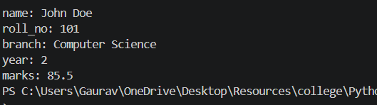
2. Program to access keys, values and items of a dictionary
student = {"name": "Alice", "age": 20, "course": "Python", "marks": 95}
print(f"Dictionary: {student}")
print(f"Keys: {list(student.keys())}")
print(f"Values: {list(student.values())}")
print(f"Items: {list(student.items())}")
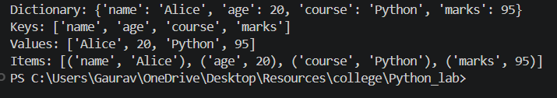
3. Program to add and update dictionary elements
student = {"name": "Bob", "age": 19}
print(f"Original: {student}")
student["city"] = "Mumbai"
print(f"After adding city: {student}")
student["age"] = 20
print(f"After updating age: {student}")
student.update({"course": "Python", "marks": 88})
print(f"After adding multiple: {student}")
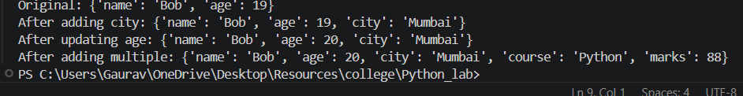
4. Program to delete elements from dictionary
student = {"name": "Charlie", "age": 21, "city": "Delhi", "course": "Python", "marks": 90}
print(f"Original: {student}")
removed = student.pop("city")
print(f"Removed 'city': {removed}")
print(f"After pop: {student}")
del student["course"]
print(f"After del: {student}")
last = student.popitem()
print(f"Removed last item: {last}")
print(f"After popitem: {student}")
student.clear()
print(f"After clear: {student}")
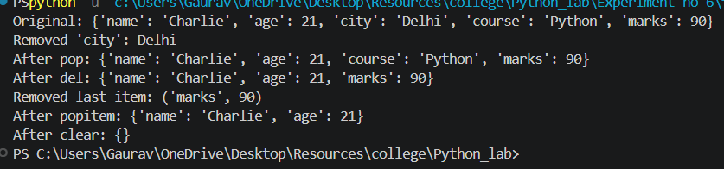
5. Program to count frequency of words in a sentence using dictionary
sentence = input("Enter a sentence: ")
words = sentence.lower().split()
freq = {}
for word in words:
freq[word] = freq.get(word, 0) + 1
print("Word frequency:")
print("-" * 20)
for word, count in freq.items():
print(f"'{word}': {count}")
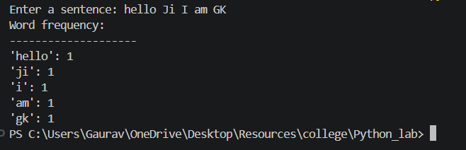
6. Program to merge two dictionaries
dict1 = {"a": 1, "b": 2, "c": 3}
dict2 = {"d": 4, "e": 5, "f": 6}
print(f"Dictionary 1: {dict1}")
print(f"Dictionary 2: {dict2}")
# Method 1: Using unpacking operator (Python 3.5+)
merged1 = {**dict1, **dict2}
print(f"Merged using unpacking: {merged1}")
# Method 2: Using update() method
dict1.update(dict2)
print(f"Merged using update(): {dict1}")
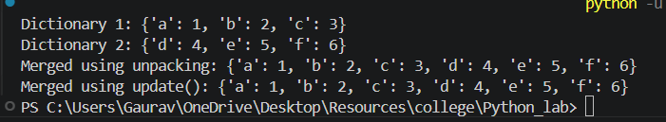
7) Program to convert hex to binary using dictionary
hex_to_bin = {
'0': '0000', '1': '0001', '2': '0010', '3': '0011',
'4': '0100', '5': '0101', '6': '0110', '7': '0111',
'8': '1000', '9': '1001', 'A': '1010', 'B': '1011',
'C': '1100', 'D': '1101', 'E': '1110', 'F': '1111'
}
hex_num = input("Enter hexadecimal number: ").upper()
binary = ''.join(hex_to_bin[digit] for digit in hex_num)
print(f"Hexadecimal: {hex_num}")
print(f"Binary: {binary}")
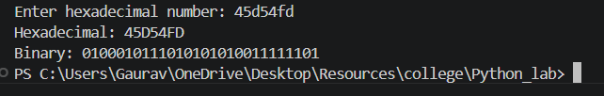
8. Program to find student with highest marks
students = {}
n = int(input("Enter number of students: "))
for i in range(n):
name = input(f"Enter name of student {i+1}: ")
marks = float(input(f"Enter marks of {name}: "))
students[name] = marks
print(f"\nStudent records: {students}")
topper = max(students, key=students.get)
print(f"Student with highest marks: {topper}")
print(f"Marks: {students[topper]}")
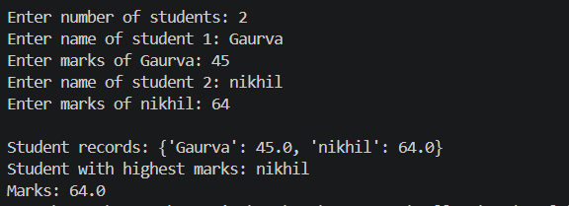
9. Program to sort dictionary by keys and values
data = {"banana": 3, "apple": 5, "cherry": 1, "date": 2, "elderberry": 4}
print(f"Original: {data}")
sorted_by_keys = dict(sorted(data.items()))
print(f"Sorted by keys: {sorted_by_keys}")
sorted_by_values_asc = dict(sorted(data.items(), key=lambda item: item[1]))
print(f"Sorted by values (ascending): {sorted_by_values_asc}")
sorted_by_values_desc = dict(sorted(data.items(), key=lambda item: item[1], reverse=True))
print(f"Sorted by values (descending): {sorted_by_values_desc}")
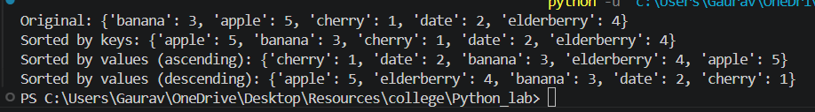
10. Program to demonstrate dictionary comprehension
squares = {x: x**2 for x in range(1, 6)}
print(f"Squares: {squares}")
evens = {x: "even" for x in range(1, 11) if x % 2 == 0}
print(f"Even numbers: {evens}")
original = {"a": 1, "b": 2, "c": 3, "d": 4}
swapped = {v: k for k, v in original.items()}
print(f"Original: {original}")
print(f"Swapped (value:key): {swapped}")
words = ["apple", "banana", "cherry", "date"]
word_lengths = {word: len(word) for word in words}
print(f"Word lengths: {word_lengths}")
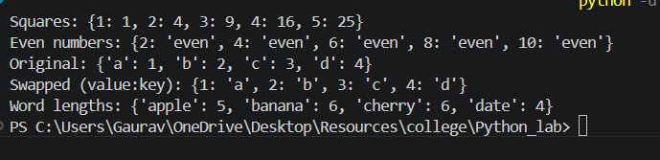

Conclusion
In this experiment, we studied dictionary operations including creation, accessing keys/values/items, adding/updating/deleting elements, word frequency counting, merging dictionaries, hex-to-binary conversion, finding student with highest marks, sorting dictionaries, and dictionary comprehension. Dictionaries are powerful key-value based data structures essential for efficient data lookup and mapping.

